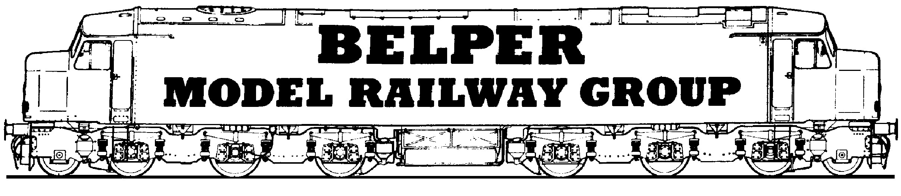Modular Layout Project

The Modular Layout Project is designed to be a group project that will allow for individual members to demonstrate and practise their own modelling skills.
The plan is for members to work at home as well as on model club nights so that they have control as to the level of progress. It is anticipated that some activities will take place on club nights to demonstrate ways of tackling issues that arise.

For the project to succeed there has to be a set of standards to which everyone must comply. These standards at present include the design and pattern of the end panels, the type and lay of the track at the ends of the boards, the positions of the track, essential connection for electrics between boards. Other standards may arise as the project develops.

The basic baseboard
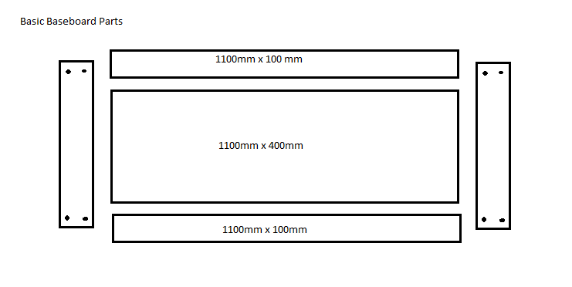
500mmx10mm
500mm x 100mm
The basic baseboard is made from Birchwood Ply.
The sides and ends are made from 12mm ply and the top is made from 9mm ply.

There is a jig for constructing the boards. The pieces are held together using 8mm x 8mm square section wood (Ramin) all glued using PVA. Nails are only used on the ends (4 per end)

End Panel

A metal template has been made to locate the position of the centre line and connecting holes. Modules will be held together using M6 bolts and nuts many of which have been provided

Track positions
Agreement has been reached that the track positions will be as follows.
Primary route will be on the centre line (200mm from 9mm ply edge)
Additional positions will be 50mm either side of the centre to allow for two track running at a future stage. Initially members are invited to add one additional track which is set 50mmm to one side of the centre line.

A small piece of baseboard fitted with an ends can be used to help with alignment.

Track
PECO Streamline Finescale Code 75 will be used on the track ends and should ideally be used on the mainlines which connect with other boards. It is possible to deviate from this standard within the track board area.

Track will be mounted on 1/8 “ cork as available from Gaugemaster.

The standard width for the cork underlay will be 35mm

Joining the boards

The M6 bolts and nuts will hold the boards together but the rails must be joined using 100mm rail pieces.
These pieces are made from Code 75 rail glued to a piece of 1/8” cork which is 100mm x 35mm. These joining pieces will be fitted with SL-110 Code 75 fishplates. The underside of the track joining pieces will be coated with a layer of clear varnish to provide stability.

Track on the board will therefore end 50mm from the board end. This is where the cork and the track on the board end. When laying the track, track should be positioned at the end so that half a sleeper gap is at the end. This will ensure that the sleeper spacing appears the same throughout the modules when they are joined.

Electrical Board Connection
Two 4mm sockets will be placed at the end of the module on the front and back sides. A total of 8 sockets per board.

Track Laying
Individual members will decide their own particular track plan for their board.
However, in order to maintain through running with other boards the main lines should if possible be made of Code 75 PECO Streamline Finescale track.

The centre line of the track should be drawn onto the board. 17.5/18mm each side of this line, two more lines should be drawn to mark the edge of the cork position.
Cork can then be cut into strips 35mm wide. Check the position of the cork before gluing.
To ensure rapid drying time on a club night and to prevent too much absorption by the cork of a wetter glue, it is suggested that the track be laid using Evo-stik contact adhesive. This does mean that determining the correct position by a dry run is paramount as removal afterwards will be difficult.
To fix thje cork, apply glue to one side of the cork strip and to the baseboard where it will be located. Wait for 5-10 minutes and fix in place.

Repeat the procedure for the track, 50mm offset from the centre line.

TRACK POSSIBILITIES
Place the track in position. The holes for the fixing pins will need to be predrilled. Using PECO track pins, this requires a pilot hole of 0.5mm. This method will allow for changes to be easily made prior to ballasting.

The track also could be glued down and this will be preferable within 25mm of the ends where the track meets the board joining pieces.

Glue track to board here. Rest can be pinned

